

**PROJECT GROUP MEMBER**

|  |  |
| --- | --- |
| ***Students Id*** | ***Students Name*** |
| ***Student1391568*** | ***Syed Muhammad Arham*** |
| ***Student1421636*** | ***Muhammad Anas*** |
| ***Student1425430*** | ***Muhammad Talha*** |
| ***Student1449759*** | ***Muhammad Hassan*** |
| ***Student1413553*** | ***Murtaza Mustafa*** |

**CURRICULUM BATCH**

**7062 2301C2**

**FACULTY**

**SIR HARIS NASEER**

**CO-ORDINATOR**

**MISS MAHA HAIDER**

**CERTIFICATE**

This is to certify that the dissertation **“Symphony Limited”** is **Syed Muhammad Arham Student 1391568, Muhammad Talha Student 1425430, Muhammad Anas Student 1421636 Muhammad Hassan Student 1449759 Murtaza Mustafa Student 1413553** in their partial fulfilment of the requirement of the award of the Aptech Computer Certified.

**ADMIN SCREENSHORTS**

**LOGIN**

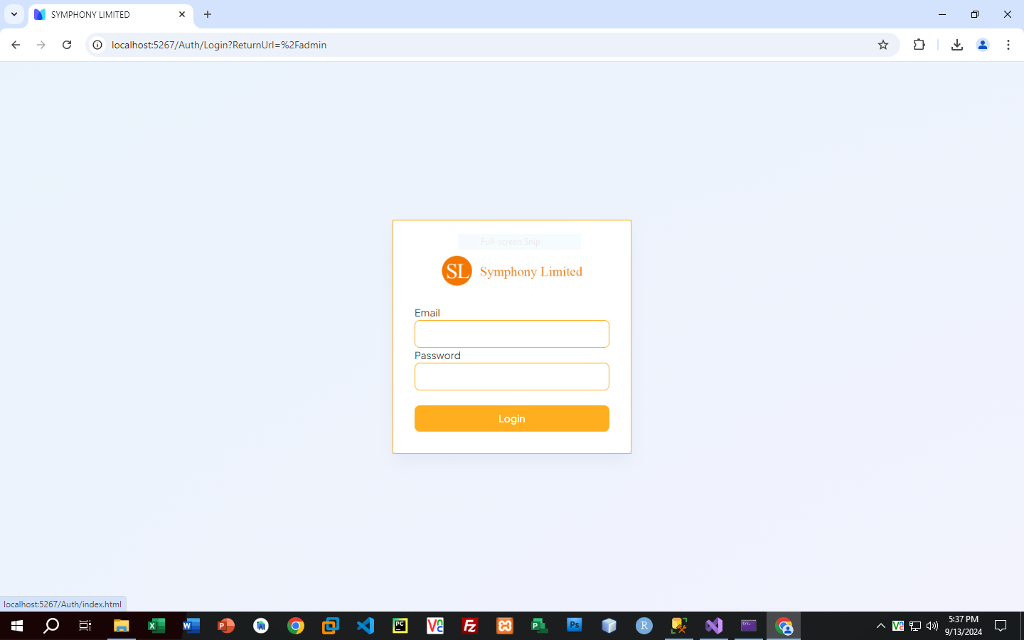

**HOME**

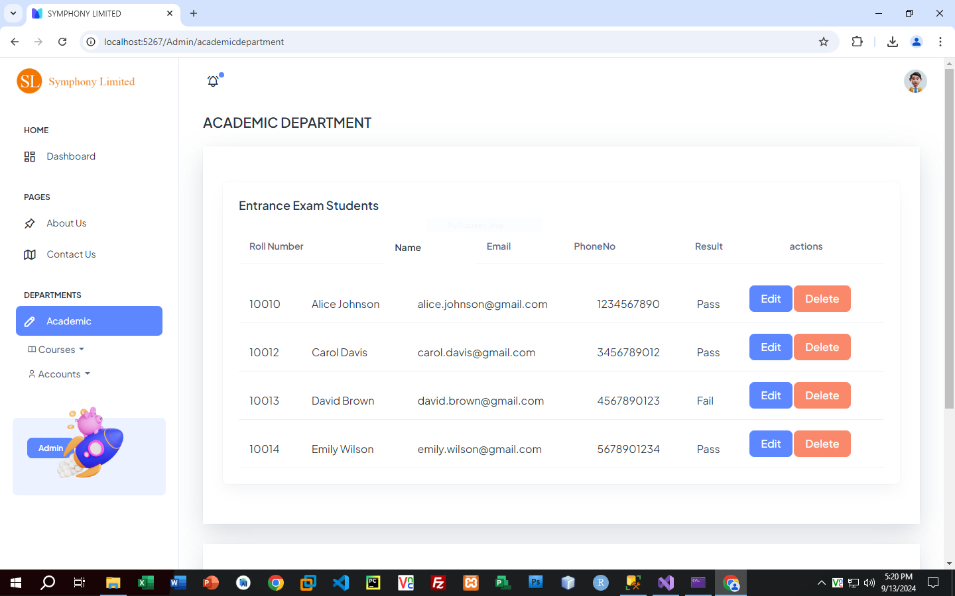

**REGISTER STUDENTS**

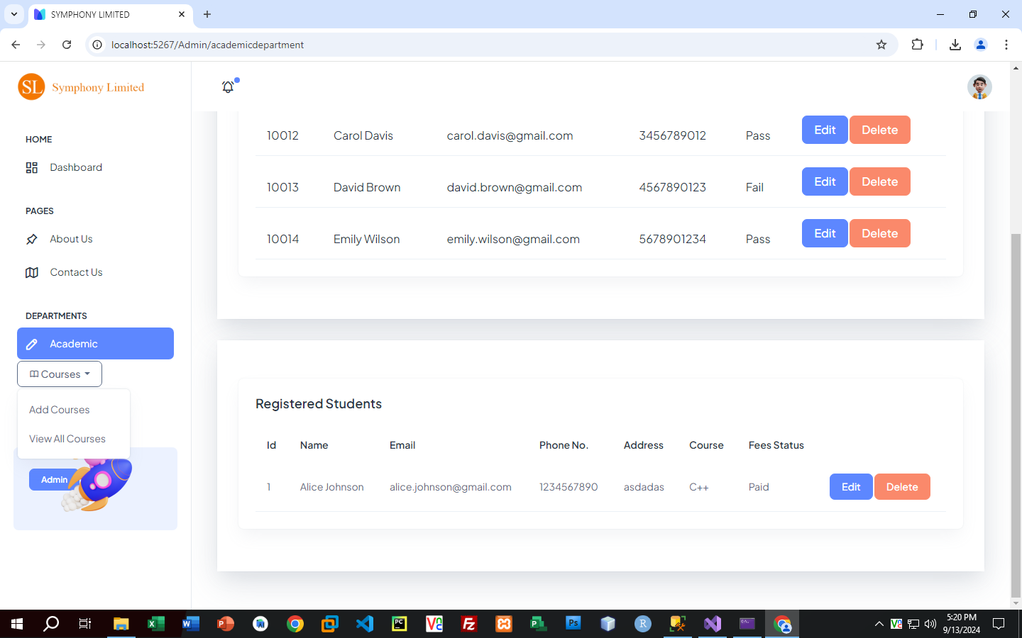

**ADD COURSE FORM**

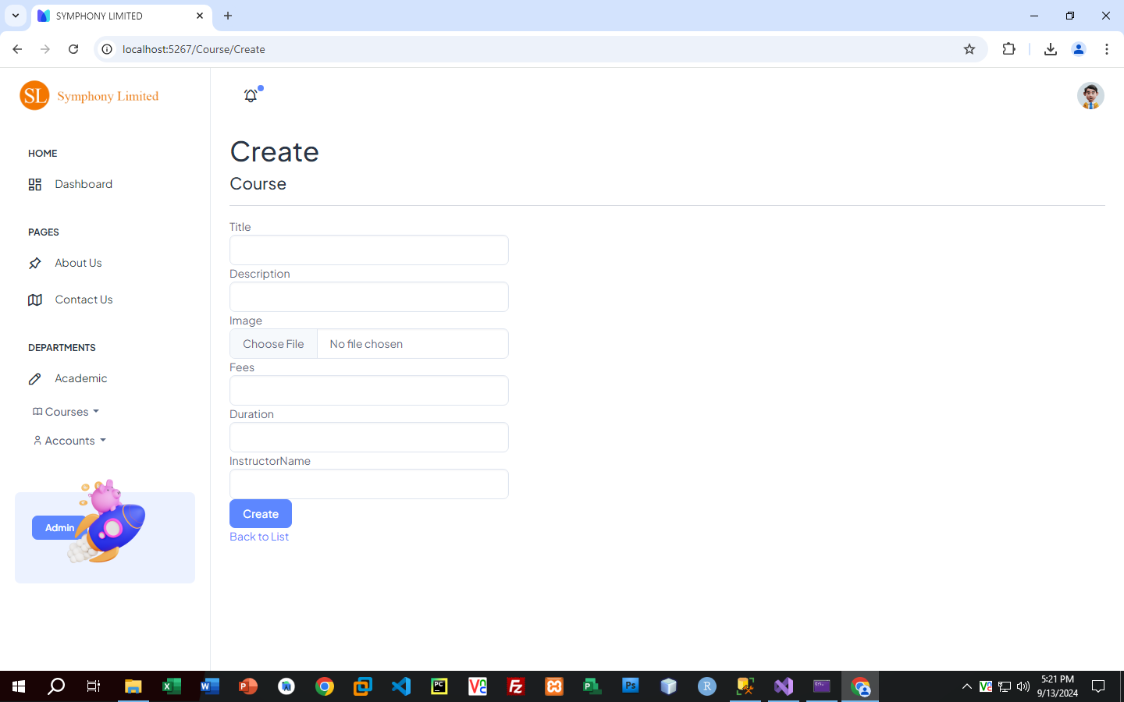

**ADD RECORD FORM**

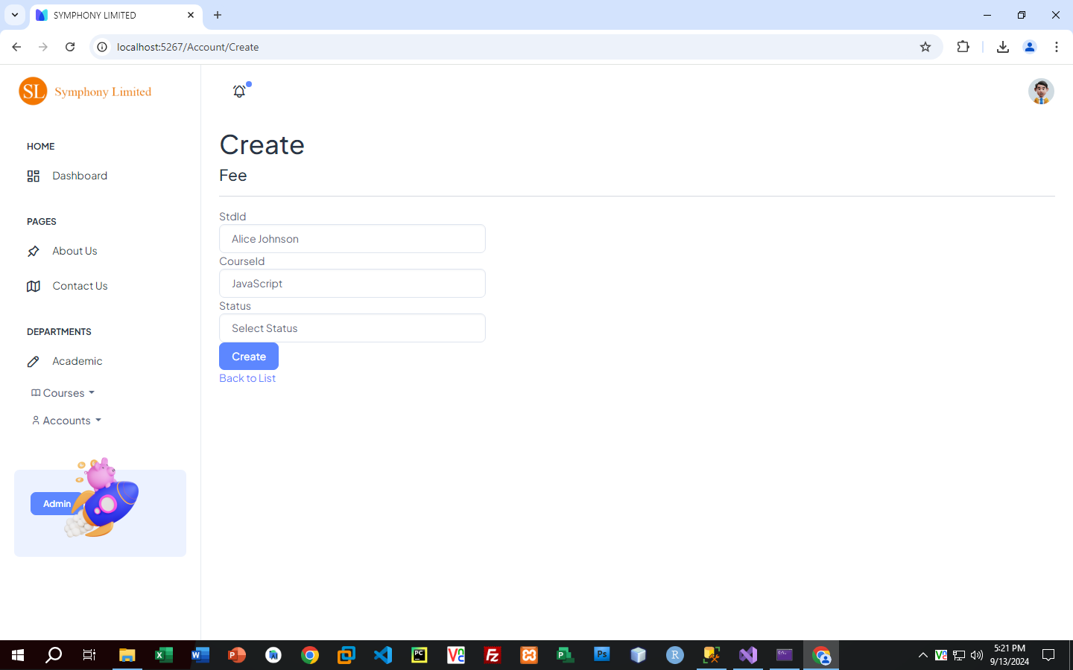

**EDIT COURSE FORM**

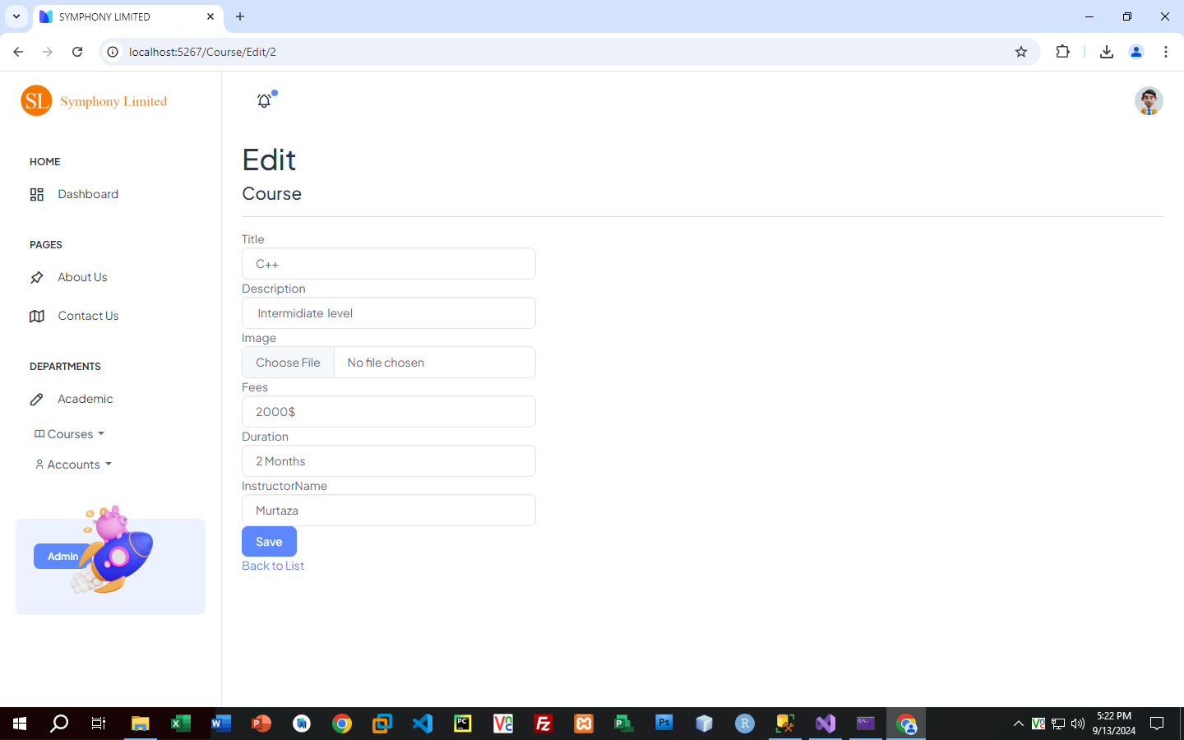

**DELETE COURSE FORM**

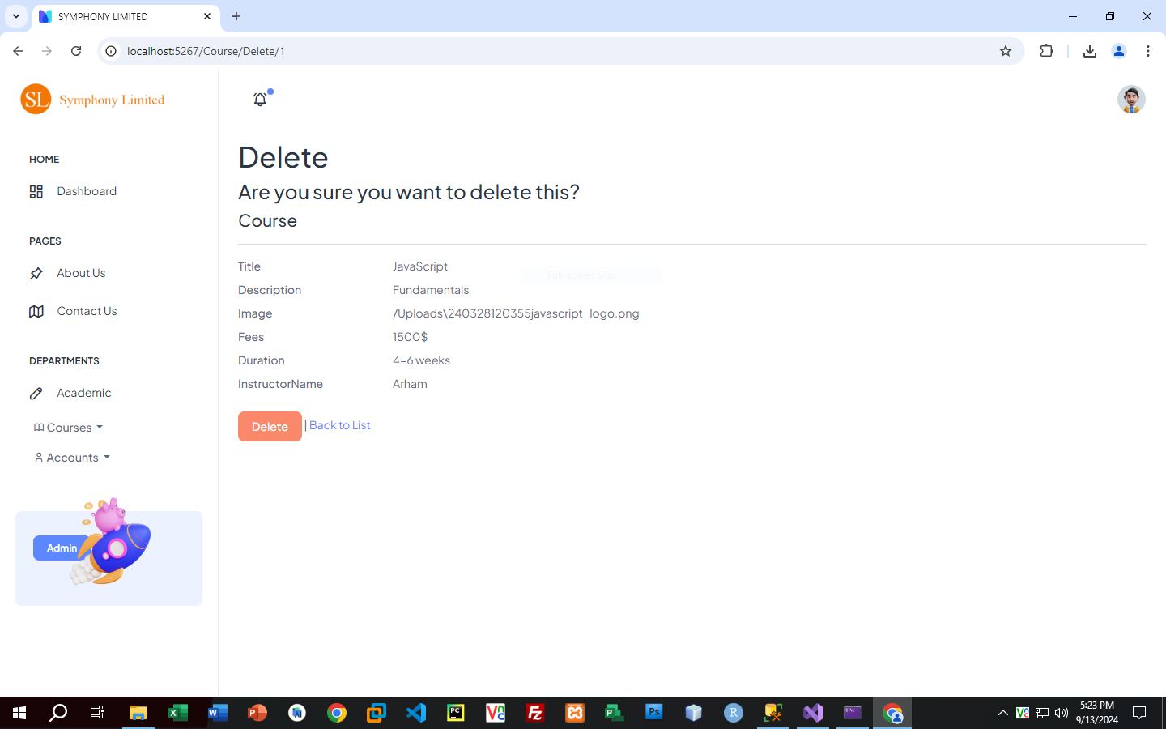

**VIEW RECORDS**

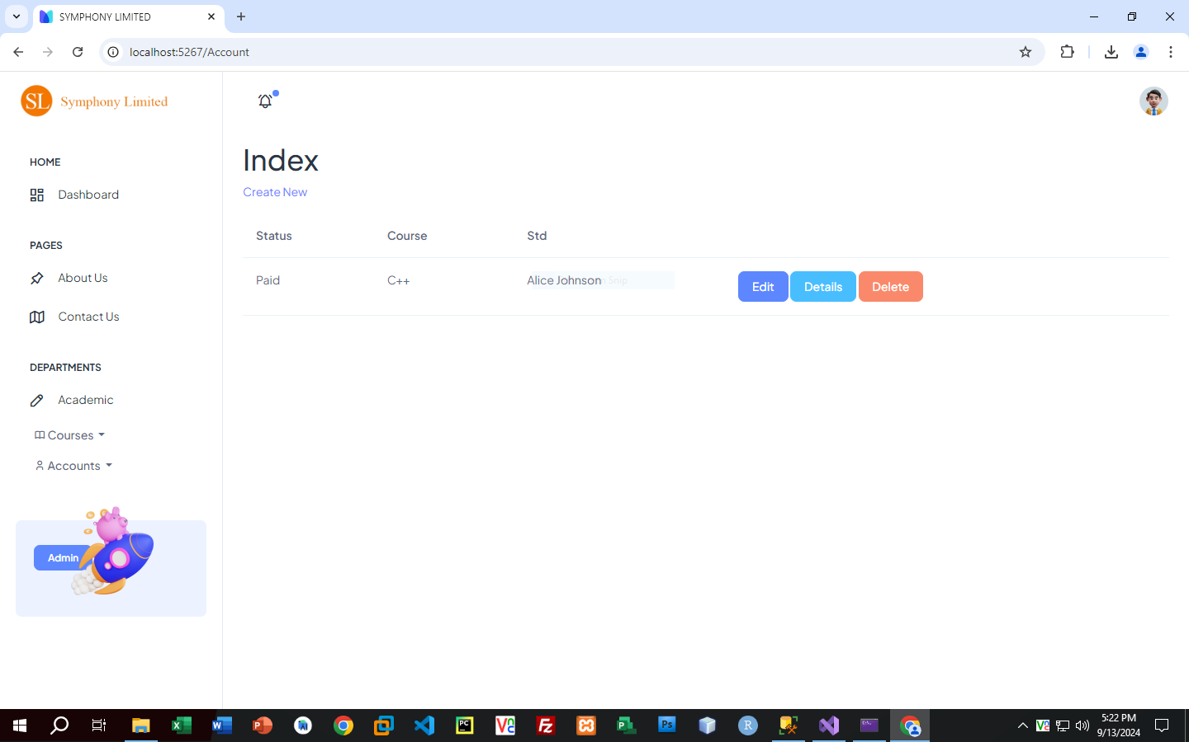

**VIEW COURSE**

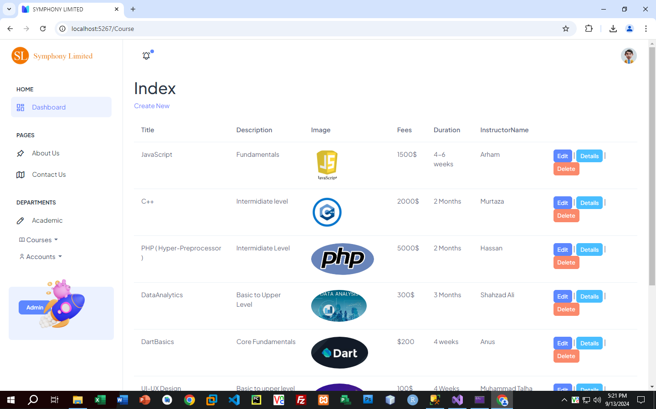

**WEBSITE SCREENSHORTS**

**HOME**



**ABOUT**

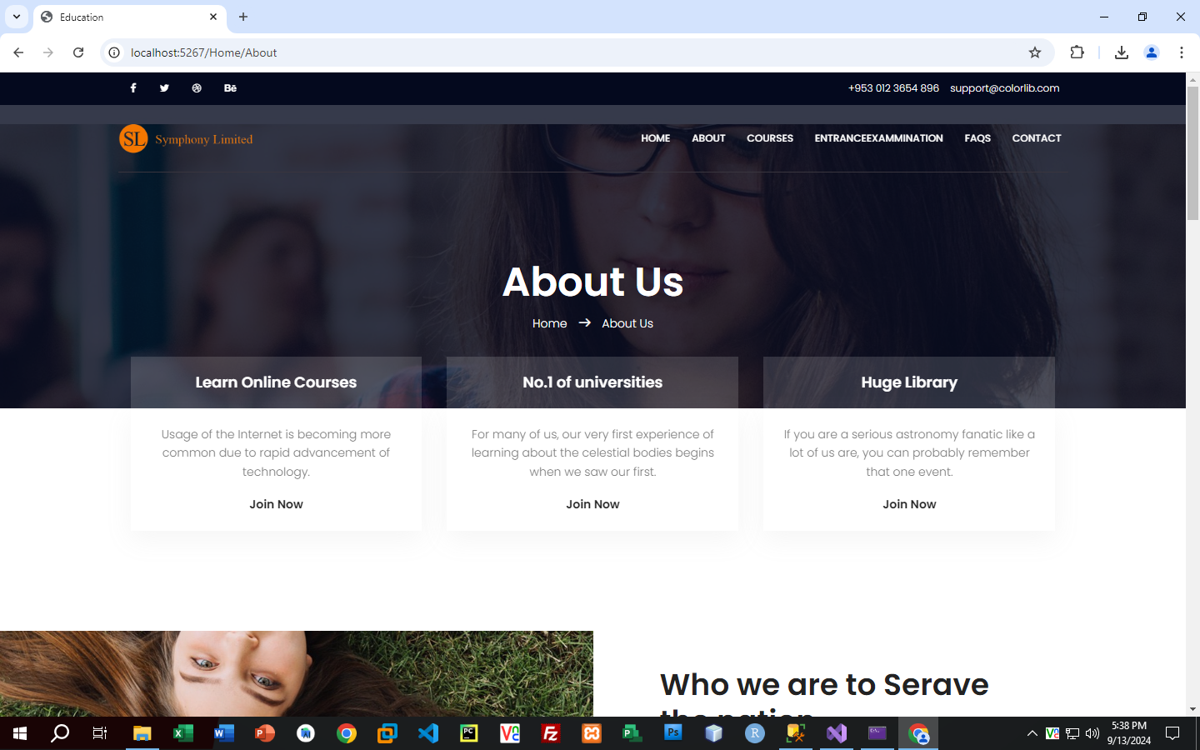

**COURSE**



**COURSE-DETAIL**

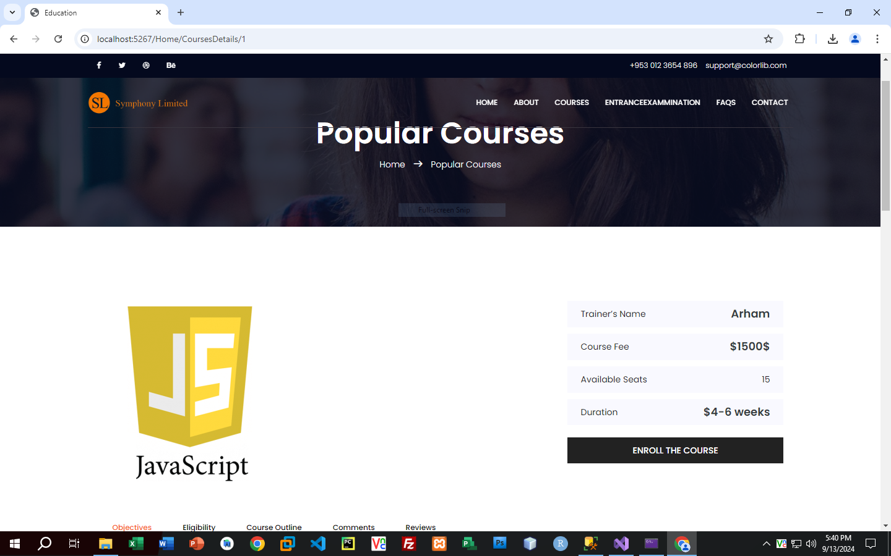

**ENTER EXAM**

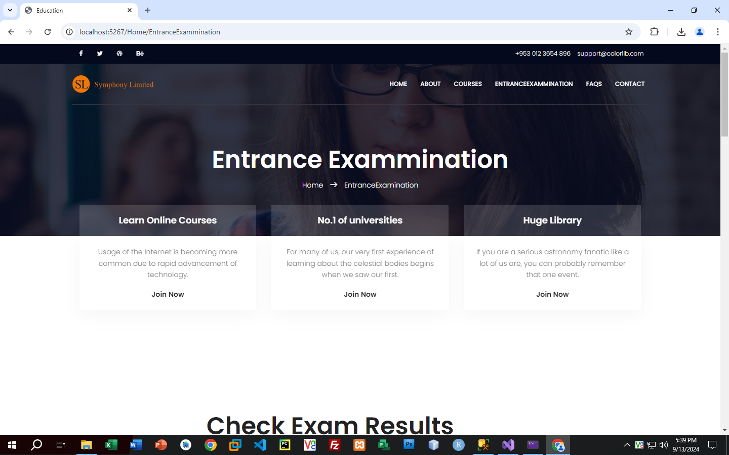

**FAQ**



**CONTACT**

